Day ____ Notes: Modeling Data
Precalculus/Trigonometry

Objectives:

- Use a graphing calculator to model data that exhibit linear, quadratic, cubic and quartic behavior by first examining a scatter plot of the data.

The scatter plot below shoes total personal savings as a percent of disposable income in the United States. Often data with multiple relative extrema (maximums or minimums) are best modeled by a polynomial function.

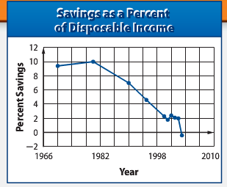

With a partner, answer the following questions.

- Describe where the graph of the data changes directions. Estimate the years?

Approximately 1980, 2001, and 2003

- Do there appear to be breaks, holes, or gaps in the graph?

No, so we can model this with a polynomial function.

- Would you expect this graph to be modeled by a linear function? Why or why not?

It would not be linear because lines cannot change direction. The data is more of a curve.

- Would you expect this graph to be modeled by a quadratic function? Why or why not?

Not really. A quadratic function has one max or min point. This graph appears to have at least 2 max points.

- What is disposable income? Your personal income after taxes. It’s the money that you have available to buy goods.
Relative Extrema:

- Relative Maximum: the point or points at which a graph changes from increasing to decreasing. (-3, 2) and (2, 1)

- Relative Minimum: the point or points at which a graph changes from decreasing to increasing. (-1, -3) and (4, -1)

NEITHER OF THESE CAN BE END-POINTS

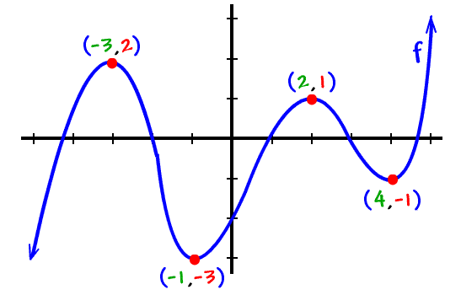

Your Turn: Find the relative extrema in this graph.

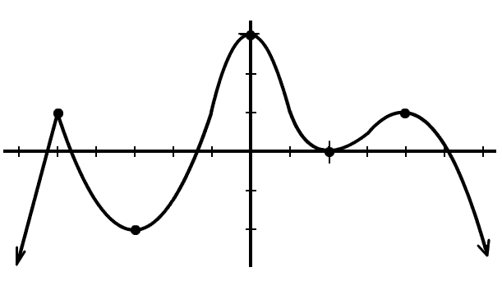

Relative Max: (-5, 1), (0, 3), (4, 1)

Relative Min: (-3, -2) and (2, 0)
Modeling Data:

Example #1: The average personal savings as a percent of disposable income in the United States is given in the table.

Year | 1970 | 1980 | 1990 | 1995 | 2000 | 2001 | 2002 | 2003 | 2004 | 2005
% Savings | 9.4 | 10.0 | 7.0 | 4.6 | 2.3 | 1.8 | 2.4 | 2.1 | 2.0 | -0.4

- Use your graphing calculator to create a scatter plot of the data and determine the type of polynomial function that could be used to represent the data.

Enter the data using the list feature of the graphing calculator. Let L1 be the number of years since 1970. Let L2 be the % Savings. Then create a scatter plot of the data.

- Write a polynomial function to model the data set. Round each coefficient to the nearest thousandth, and state the correlation coefficient. Explain what the correlation coefficient means in terms of this situation.

$$f\left(x\right)= -0.009x^{2}+0.033x+9.744$$
$R^{2}=.961$ strong correlation graph is a good fit for the data.

- Use the model you found in part b to estimate the percent savings in 1993.

5.94%

- Use the model to determine the approximate year in which the percent savings reached is 6.5%.
1991

Practice: The table below shows a town’s population over an 8-year period. Year 1 refers to the year 2001, year 2 refers to 2002, and so on.

Year | 1 | 2 | 3 | 4 | 5 | 6 | 7 | 8
Population | 5050 | 5510 | 5608 | 5496 | 5201 | 5089 | 5095 | 4675

- Enter the data into your calculator. Let L1 be the years and L2 be population. Look at the scatter plot of the data and try to decide which function would better fit the data: a quadratic or a cubic.
Cubic

- Write a polynomial function to model the data. Round each coefficient to the nearest thousandth, and state the value of the correlation coefficient. Use your calculator to run the correct regression to do this.

$$f\left(x\right)=10.020x^{3}-176.320x^{2}+807.469x+4454.786$$
$$R^{2}=0.89$$

- Use the model to estimate the population of the town in the year 2012.
6069

- Use the model to determine the approximate year in which the population reaches 10,712.
2015

