Mathematical Modeling Group Project
Precalculus/Trigonometry

Creating an open-topped box of maximum volume is a very common problem seen in calculus. The goal is to optimize resources by enclosing the most volume possible given the constraint of the size of the construction material. In this example, we will use a rectangular piece of paper.

Step #1: In your group, cut out congruent squares from each corner and fold the sides in order to create an open-topped box. Remember, your goal is to maximize the volume of the box.

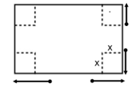

Step #2: Using a ruler, measure the length, width, and height of the box to the nearest tenth of a centimeter.

Length (longest side):

Width:

Height:

Step #3: Calculate the volume.

Step #4: Record your values in the table on the board.

Step #5: Using the data from the board, create a scatter plot of volume versus height. Let L1 be the height and let L2 be the volume.

Step #6: What type of polynomial function could we use to model this data? Explain how you know.

Step #7: Use the regression feature of the calculator to find a function to model the data. Which regression provides a better fit to the data? How do you know?

Step #8: Find the maximum volume of the box.

Step #9: What size square should be cut from each corner to maximize the volume?

Step #10: What are the dimensions of the box that provide the maximum volume?

Problem #2: Jeannie wishes to construct a cylinder that is closed at both ends. The figure shows the graph of a cubic polynomial function used to model the volume of the cylinder as a function of its radius if the cylinder is constructed using $150π cm^{2}$ of material. Use the graph to answer the questions below. Estimate values to the nearest half unit on the x-axis, and to the nearest 50 units on the y-axis.

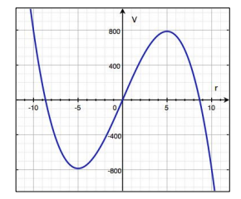

- What is the domain of the volume function? (i.e. what are the largest and smallest radius lengths possible?) Explain.

- What is the most volume that Jeannie’s cylinder can enclose?

- What radius yields the maximum volume?

- The volume of a cylinder is given by $V= πr^{2}h$. Calculate the height of the cylinder that maximizes the volume.

Problem #3: For a fundraiser, members of the math club decide to make and sell t-shirts that say “Pythagoras may have been Fermat’s first problem but not his last!” They are trying to decide how many t-shirts to make and sell at a fixed price. They surveyed the level of interest of students around school and made a scatter plot of the number of t-shirts sold (x) versus profit (y) shown below.

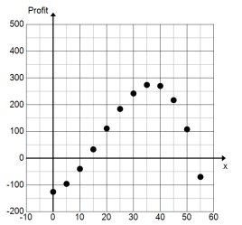

- Identify the y-intercept. Interpret its meaning within the context of this problem.

- If we model this data with a function, what point on the graph represents the number of t-shirts they need to sell to break-even? Why?

- Approximately how many t-shirts to they need to sell at a minimum to make a profit?

- How many t-shirts do they need to sell to maximize profits?

- What is the maximum profit?

- What factors would affect the profit?

- What would cause the profit to start decreasing?

Problem #4: The owners of Dizzy Lizzy’s Amusement Park are studying the wait time of their most popular roller coaster. The table below shows the number of people standing in line for the roller coaster t hours after the park opens.

One analyst made a scatter plot of the data and decided that a cubic function should be used to model the data. His scatter plot and curve are shown below.

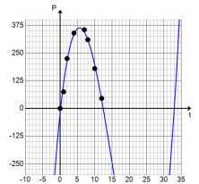

Another analyst disagreed and said that a quadratic function should be used.

- Use the data above and your graphing calculator to create a quadratic model of the data. Let L1 be the hours after the park opens and L2 be the number of people in line. Write the equation below rounding all coefficients to the nearest hundredths.

- What is the correlation coefficient?

- Which model seems to be a better fit?

- Estimate the time at which the line is the longest.

- Estimate the number of people in line at that time.

- Estimate the t-intercepts of the function used to model the data.

- Use the t-intercepts to write a formula for the function of the number people in line after t hours. Hint, you are going to have to calculate the leading coefficient. Use the maximum point to do this.

- What would be a reasonable domain for your function? Why?

- Use your function to calculate the number of people in line 10 hours after the park opens.

- Compare the value from part “i” to the value in the table. What do you notice?

- Graph your function and the one generated by the graphing calculator to complete the table. Round all values to the nearest whole number.

- Based on the table, which model is more accurate at t = 2 hours? t = 10 hours?

