Day ____ Notes: Functions

Objective #1: Determine Whether a Relation Represents a Function

Define: Relation

Define: Function

Define: Domain

Define: Range

Example #1: Determine whether the following relation is a function.

The domain represents employees of a company, and the range represents their base salary.

Domain Range

Dave $100

Sandi $150

Maureen $200

Dorothy

Is this relation a function? Why or why not?

Example #2: Determine whether the following relation is a function.

The domain represents the employees of a company, and the range represents their phone numbers.

Domain Range

Dave 555-2345

Sandi 549-9402

Maureen 930-3956
555-8345
Dorothy 857-0192

Is this relation a function? Why or why not?

Example #3: Determine whether each relation represents a function. For those that are functions, state the domain and the range.

- {(1, 4), (2, 5), (3, 6), (4, 7)}

- {(1, 4), (2, 4), (3, 5), (6, 10)}

- {(-3, 9), (-2, 4), (0, 0), (1, 1), (-3, 8)}

Hint: If ______ repeats, then the relation is not a function.

Objective #2: Find the Value of a Function (Evaluate a Function Given a Value)

Function Notation: f(x) is read as ____________________.

Sometimes it is helpful to think of a function f as a machine that receives input from the domain, manipulates it, and outputs the value into the range.

Define: Independent Variable

Define: Dependent Variable

Example #3: For the function G defined by $G\left(x\right)=2x^{2}-3x,$ evaluate

- G(3)

- G(x) + G(3)

- G(-x)

- -G(x)

- G(x+3)

Objective #3: Find the Domain of a Function from an Equation

The domain of a function is always _____________________, denoted by writing _________ unless the function involves one of the following:

If there is a square root, find the domain exclusions by

If there is a variable in the bottom of the fraction, find the domain exclusions by

Example #4: Find the domain of each of the following:

- $f\left(x\right)=x^{2}+5x$

- $f\left(x\right)=\frac{3x}{x^{2}-4}$

- $f\left(x\right)= \sqrt{x-5}$

- $f\left(x\right)= \sqrt{4-3x}$

- $f\left(x\right)= \frac{1}{\sqrt{x+10}}$

Objective #4: Identify the Graph of a Function

Define: Vertical Line Test

Example #5: Which of the following graphs are graphs of functions?

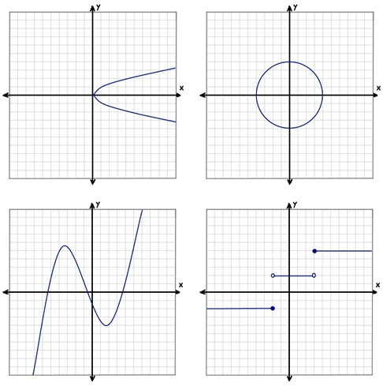

Objective #5: Obtain Information from the Graph of a Function

Example #6: Let’s look at page 106 in our text books. Find Example 8 and answer the following questions.

- What is f(0)? What is $f(\frac{3π}{2})$? What is f(3$π$)?

- What is the domain of f?

- What is the range of f?

- List all of the intercepts as ordered pairs.

- How often does the line y = 2 intersect the graph?

- For what values of x does f(x) = -4?

Objective #6: Obtaining Information about the Graph of a Function from the Equation of the Function

Example #7: Consider the function: $f\left(x\right)= \frac{x}{x+2}$

- Is the point $\left(1,\frac{1}{2}\right)$ on the graph of f?

- If x = -1, what is f(x)? What point is on the graph of f?

- If f(x) = 2, what is x? What point is on the graph of f?

Objective #7: Use the Difference Quotient

One of the basic definitions in calculus employs the ratio $\frac{f\left(x+h\right)-f(x)}{h}, h≠0$

This ratio is called the ___________________ __________________.

Example #8: For $f\left(x\right)=x^{2}-4x+7,$find each of the following.

- f(x)

- f(x + h)

- $\frac{f\left(x+h\right)-f(x)}{h}$

Example #9: For $f\left(x\right)=5x^{2}+3x+1$, find each of the following:

- f(3)

- f(3 +h)

- $\frac{f\left(3+h\right)-f(3)}{h}$

Day ____ Notes: Characteristics of Functions

Objective #1: Find the Average Rate of Change of a Function

In the previous section, we talked about the difference quotient. That concept is used regularly in calculus. The difference quotient can also be called the _______________ ____________ __ _______________ of a function.

In fact, if you have two points on the graph of any function, the difference quotient, or the average rate of change, will give you the slope of the line connecting those two points. Since this line intersects the graph of the function twice, it is called a ____________ _____________.

In your science classes you may have dealt with instantaneous rate of change. That was the slope of the ________________ _____________ to the function because it intersected with the function only once.

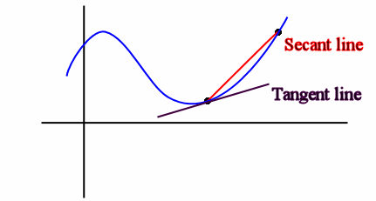

Example #1: Use the function: $f\left(x\right)=2x^{2}-3x$

- Find the average rate of change from 1 to x. (Since we are using a variable, our final answer will be an expression – not a number).

- Use the result from part “a” to find the slope of the secant line containing the points
(1, f(1)) and (2, f(2)).

Objective #2: Determine on which intervals a graph is increasing, decreasing, or constant. Then use this information to find the maxima and minima of the function.

Define local (relative) maxima:

Define local (relative) minima:

Define absolute (global) maxima:

Define absolute (global) minima:

Example #2: Let’s look in our books at page 121 and find example 4. Answer the questions using the graph.

- At what number(s), if any, does f have a local maximum?

- What are the local maxima?

- At what number(s), if any, does f have a local minimum?

- What are the local minima?

Objective #3: Determine if a function is even or odd (or neither) from its graph and from its equation.

Define: Even Function

Define: Odd Function

Example #3: Look at page 122 in your work, and find example 6. Answer the following.

Determine whether each graph given in figure 19 is the graph of an even function, an odd function, or a function that is neither even nor odd.

a)

b)

c)

Example #4: Determine whether each of the following functions is even, odd, or neither using Algebra.

- $f\left(x\right)=x^{2}-5$

- $g\left(x\right)=x^{3}-1$

- $h\left(x\right)=5x^{3}-x$

- $F\left(x\right)=$|x|

