Entering Data into the TI-83 Plus and Running Regressions

How to Enter Data

Step #1: Clear the RAM by pressing 2nd, +, 7, 1, 2. The screen should display “RAM Cleared.”

Step #2: Press the STAT button.

Step #3: Make sure that “1: Edit” is highlighted and press ENTER.

Step #4: You should see a table with column headings of L1, L2, and L3. The data for the variable that would be on the “x” axis should be entered into the L1 column. Your data for the “y” variable should be entered into L2. We will not be using L3. Press ENTER after you type in each data point.

How to Graph a Scatter Plot of the Data

Step #1: Press 2nd and then Y=

Step #2: With the first row, “1: Plot1” highlighted, press ENTER.

Step #3: Highlight the word “ON” and press ENTER. Under “Type,” make sure the scatterplot logo is highlighted (first option in the first row). Make sure “XList” is set the L1 and “YList” is set to L2.

Step #4: Press the GRAPH button.

Step #5: Press the ZOOM button. Choose option “9: ZoomStat.” You should be able to see a scatterplot of your data.

How to Run Different Kinds of Regression Analysis

Step #1: Turn Diagnostics on by pressing 2nd and then “0” to bring up the catalog of functions on the calculator. Press the $x^{-1}$ key to be taken to the “D” words in the list. Use the arrow key to scroll down until you see “DiagnosticOn.” Press ENTER. Press ENTER again. The calculator screen should display a confirmation saying “Done.”

Step #2: Press the STAT button. Use the arrow key to go to the right and highlight “CALC.” Use the arrow key to scroll down to choose the correct test based on your scatterplot. We will either be running choice 5: QuadReg (quadratic regressions for parabolas) or choice 6: CubicReg (cubic regressions). Once your choice is highlighted, press ENTER. On the calculator screen, you should see your choice and a blinking cursor. Press ENTER again. Your data will be displayed.

(Turn this paper over for a diagram of important calculator buttons mentioned in this text.)

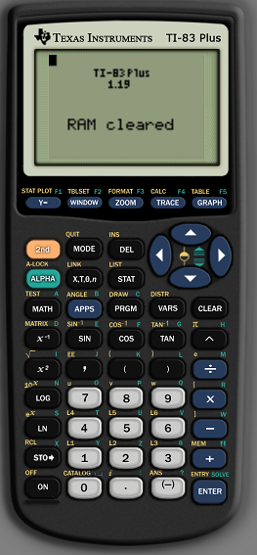
Display Scatterplot.
Turn on Diagnostics so that you can view the Correlation Coefficient ($R^{2}$).
Enter Data and Run Regressions.
Turn Stat Plots on to switch from a regular graph view to a scatterplot of the points.

